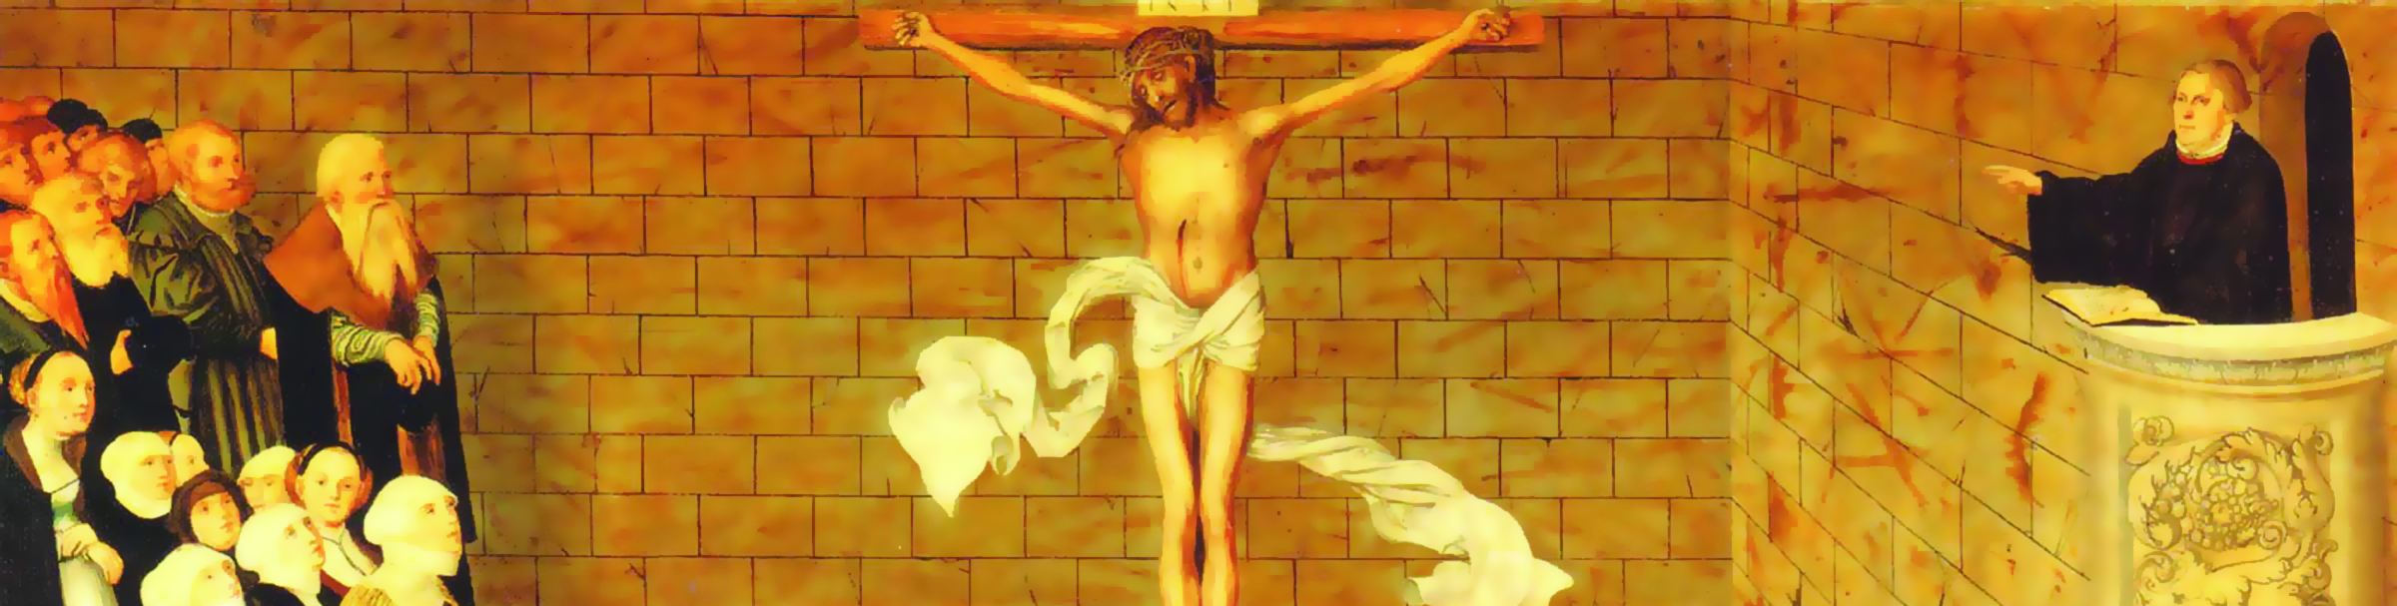
Vol. 15 No. 5
May/June 2012
Imitating Scriptural Variety in Our Preaching Styles
Proclaim Grace! Key Issue #10
Use any or all of the following questions for personal reflection or group study. Feel free to pick which applications interest you most; even if you only complete one or two you’ll benefit.

It is suggested that a typical WELS preacher reverts to a default form learned at the seminary: deductive with basic theme and parts. Is this your default form, or is there another? How does the idea of learning more forms sound to you?

“An inspired text has a right to tell me not only what to say, but also how it would like to say it” (p. 1). How do you determine what particular form (how you say it) each sermon takes? What and where are the triggers or clues you look for?

MATCHING
After reading page 1, match the descriptions to the name of the literature form listed below.

__________ sparks meditation by comparing the kingdom of God with the city of man.

__________ parades a dazzling pageant before the mind’s eye to remind us that God wins

__________ embodies and elicits emotion with its images, hyperbole, and self-disclosure

__________ carry us along in a flow of logic...to the heights of delight with doxology and prayer

__________ brief and witty summaries of wisdom, require us to contemplate their meaning

__________ prompts identification as we walk in the shoes of biblical characters

Poetry – Narrative – Proverbs – Parables – Epistles – Apocalypse

- Experiment—Ask a few of your members to complete the matching exercise above. How much do they really know about form? Would it make a difference in your preaching?

- Activity—Individually or as a group, find a shining biblical example of a text for each of the six forms described above.

“Whoever goes to the Bible in search of what to preach but does not linger long enough to learn how to preach has left its pages much too soon” (p. 2). After reading, “May I Ask Another Question?” on p. 2, list three texts you’ll be preaching in the weeks or months ahead. Before performing a thorough text study that identifies what the text says, pay attention to how the text says it. Answer the questions on p. 2 for each text in anticipation of incorporating its specific genre in the sermon.

Read “Never Sacrifice Substance for Style” on p. 2. Which of the five key points do you feel you best learned as part of your homiletics training? Which of the five have you learned more by experience than schooling? Which would you like to pursue as needing the most attention in your preaching right now? Identify two “next steps” that you’ll take for improvement in this area.

Utilize the “hints of what to look for in narrative” on p. 3 for your next three sermons on narrative texts. Treat the bullet points as a checklist during your sermon preparation. This “hands on” learning takes no outside time as part of your sermon studying! Better yet, perform this activity as a group and share what you discover.

Based on the wise words from Meyer and Augustine on p. 4, make a list of at least three cautions that might cause a pastor to be wary of the art of preaching. Then identify responses that answer these concerns and support the art of preaching. If you want to take this to the next level, write a dialogue between two people debating about the art of preaching…and perform it among a group of preachers.

