SERVICE OF CONFESSION & ABSOLUTION

Stand
INVOCATION
M: In the name of the Father and of the Son and of the Holy Spirit.
C: Amen.

CONFESSION & ABSOLUTION
M: Children of God, let us humbly come before our Creator and acknowledge our many sins to him.

Moment for private confession

Cantor or choir sings:
I confess to you, O Lord, that I have sinned.
I confess to you, O Lord, all my sin within.
I have failed to live for you in the things I say and do,
And have fallen short of living in your love.

Lord, have mercy on me.
Lord, have mercy, set me free.
O forgive me, Lord, I pray, and take my sin away,
By the cross and empty grave for my soul.

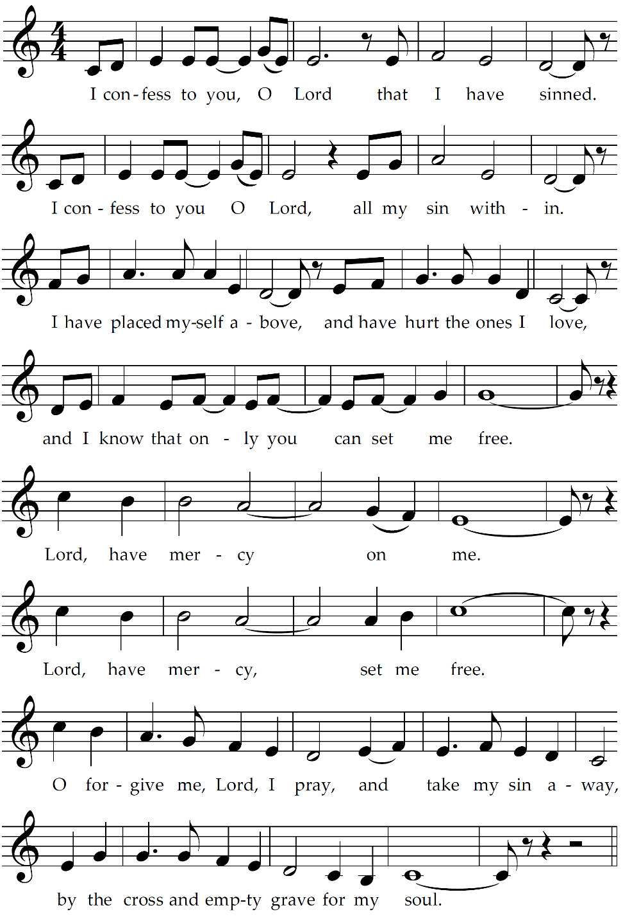
All:

Cantor or choir:
Take us back to the water; wash away our sins.
Welcome us, O Father, back to your home again.
Bless your sons and daughters,
And let the feast begin, let it begin.

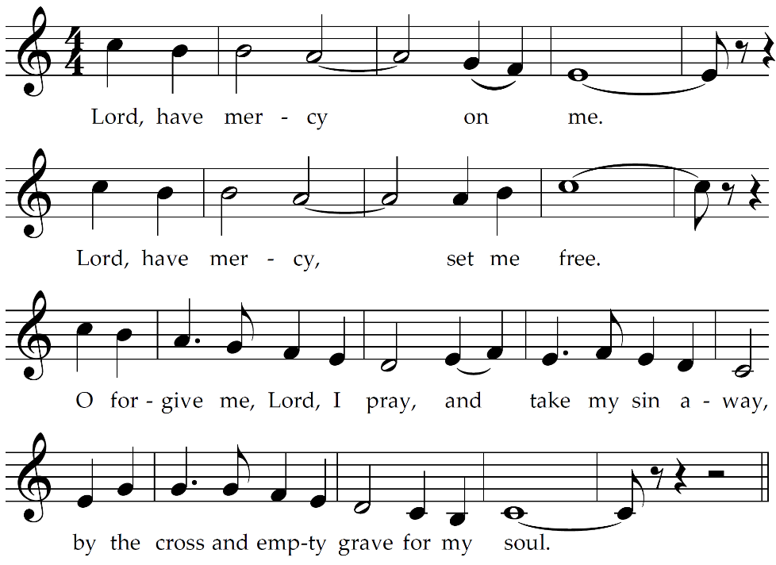
All:

M: The Almighty God, Father, Son, and Holy Spirit, has forgiven all your sins. By your baptism, you are born again and made a dear child of your Father in heaven. God strengthen you to live in the grace of your baptism all the days of your life. Peace be with you.
C: Amen.

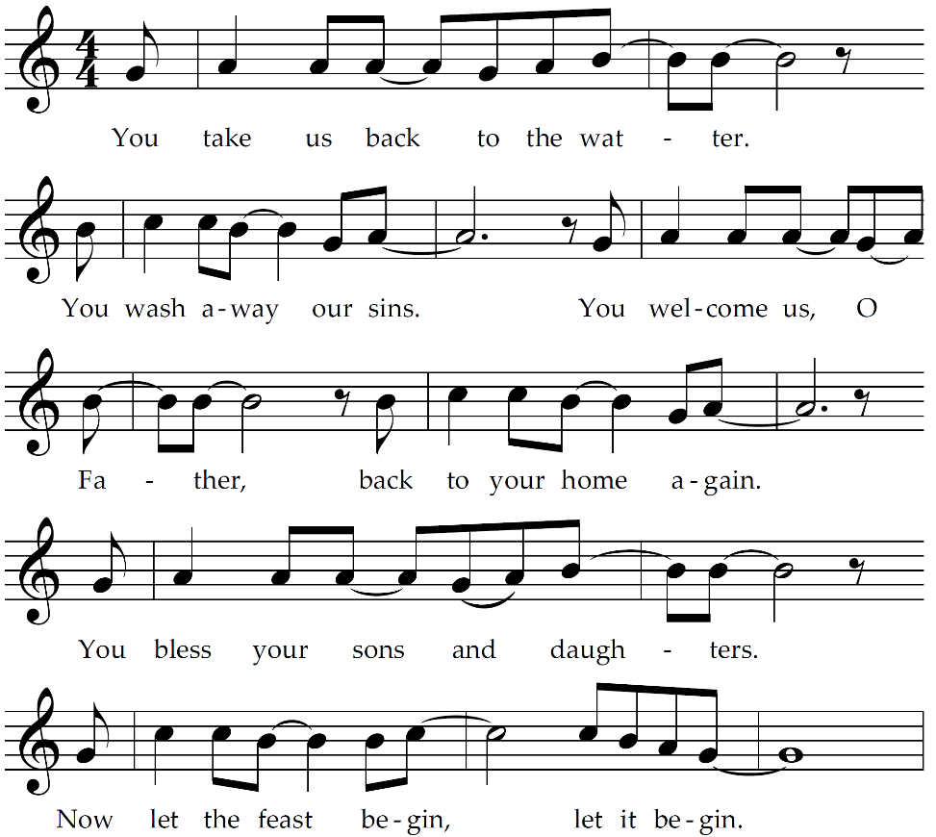
All:

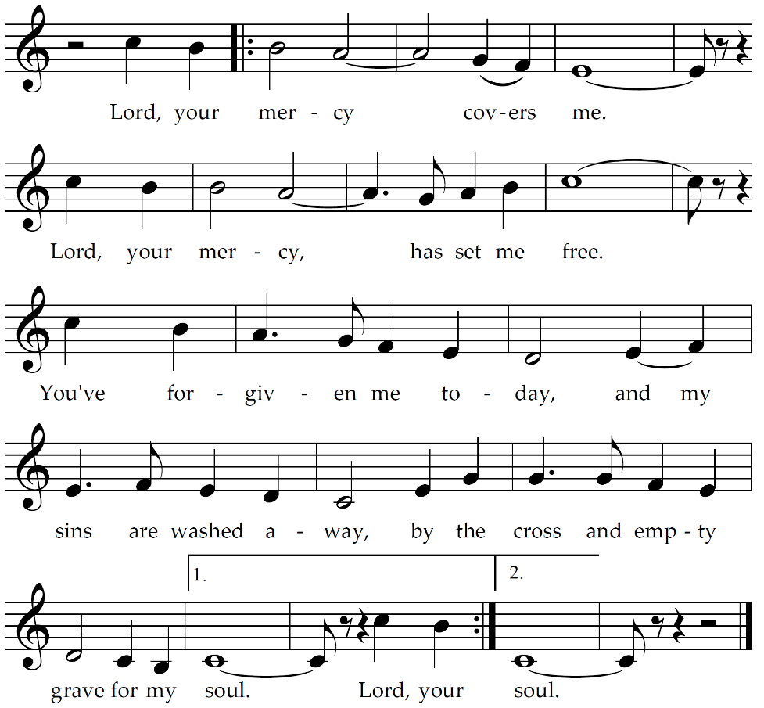

PRAYER
M: Grant to your people, O God, comfort and peace in your forgiveness that we may find strength to leave our sins, honor you, and serve those around us; through Jesus Christ, our Lord.
C: Amen.
Be seated

DEVOTION

Stand
LUTHER’S MORNING PRAYER
C: I thank you, my heavenly Father, through Jesus Christ your dear Son, that you have kept me this night from all harm and danger. Keep me this day also from sin and every evil, that all my doings in life may please you. Into your hands I commend my body and soul and all things. Let your holy angel be with me, that the wicked foe may have no power over me. Amen.

BLESSING
M: The Lord bless you and keep you.
The Lord make his face shine on you and be gracious to you.
The Lord look on you with favor and give you peace.
C: Amen.

“Confession” by Michael A. Schmid; Copyright © 2008 Michael A. Schmid, c/o True Vine Music, Napa, CA.

