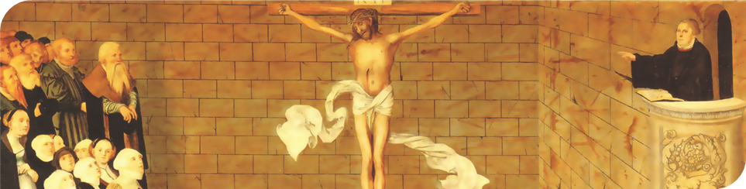
Vol. 14 No. 5
May/June 2011
Making the Most of Time in the Word
Proclaim Grace Key Issue #4
Use any or all of the following questions for personal reflection or group study. Feel free to pick and choose which applications interest you most; even if you only complete one or two you’ll benefit.

On page 1, two points are shared for why personal devotional study of the Word is different from study for sermons.

If you were to present a case to your church leaders that you desire more personal time “alone with Christ” – meaning your schedule changes – which point would they more readily understand and support? On what basis? Compare your thoughts to those of other pastors.

Recall a time in your life and ministry when you experienced any of the following:
- “A trap lurks whenever Scripture study’s final purpose is a ‘product’ for others.”
- “Weariness in ministry.”
- “Schedule pressures turn ministry into a forced march through a broad devotional desert.”
- Through the faithful study of Scripture “Rejoice!” becomes the “overflow of what has captured our hearts and impacted our lives.”
- Jesus calls preachers “away from the siren summons to success.”
- Preachers “see the patience that Jesus still has even for his pastor.”
- “Lost in wonder and awe at the love … of Christ.”

Describe the circumstances. What did you learn?

Meditatio – What are some negative connotations of the concept of meditation that run through the mind of Lutheran theologians? In keeping with our Lutheran heritage, meditation remains focused on the Word. What are some beneficial meditation practices that help the Lutheran student of the Word to gain more from his time in the Word (p. 2)? What have you found most useful? What would you like to try that you have not up to this point?

Oratio – Eugene Peterson refers to prayer as the second word; we learn to speak it by listening to the first Word. God’s Word. Much like a toddler learns to speak by imitating what she hears from others. The basis for our prayers is what we learn of God by faith. “As we ponder God’s promises, God arms us with words.” Not preaching in our prayers, mind you, but petitioning the promises of God “we seize him and refuse to let go.” If you were to inject more of God’s Word in your prayers, and less of your own words, what would that look like? Where would you start? Write a short prayer based on this encouragement and share it with others who do the same.

Tentatio – Prepare to relate a personal story to your group about a time when suffering drove you deeper into God’s Word.

To which side do you lean as a pastor-theologian – People Person or Book Worm?

Find 5 statements, phrases, or words on p. 3 that jump off the page at you. Record on a note card or your mobile phone the 3 that you think can impact you most in the next month. Discuss your top 3 choices with a group, and afterwards choose one as your motto for the next month. Inscribe it somewhere, somehow, so that it noticeably cheers you on.

“What a rich heritage of years reading and hearing the very sounds and syllables the Spirit brought from heaven … Let’s encourage one another to reclaim, maintain, or strengthen these skills” (p. 4)!

Although there are many blessings of studying the original language to prepare a sermon, if there is one blessing of such study that you never want to lose, what is it?

Challenge yourselves as a group to submit at least one idea at Grow in Grace (wlsce.net) related to key issue #6: Partnering with Peers.

What have you found helpful in working with other pastors in preaching, whether in getting ready to preach or gaining objective feedback after preaching?

