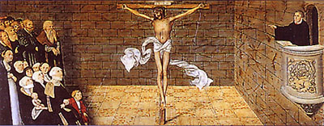
He who has ears
let him hear! Matthew 11:15
A Bible study designed to help hearers define faithful preaching so they can listen with more informed ears and provide more informed feedback

Lesson #1 – February 21, 2010
“Faith comes from hearing the message” (Romans 10:17)
What Is the Purpose and Power of Preaching?

Introduction

“There is nothing that attaches people to the church as does good preaching.” (The Apology to the Augsburg Confession, Article XXIV)

The graph below comes from the book Surprising Insights from the Unchurched by Thom Rainer. The graph (page 21) represents responses from 353 interviews with formerly unchurched people who became part of a church. How does this graph support Melanchthon’s statement in our Lutheran Confessions?
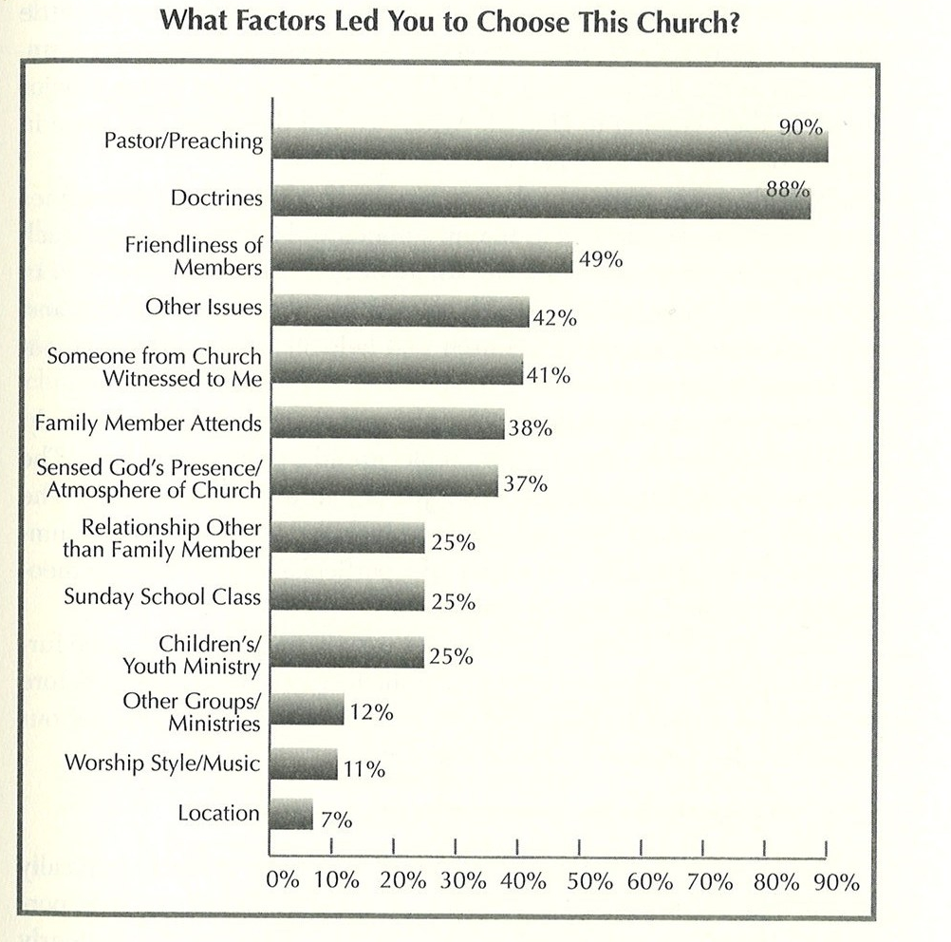

Part One: God’s Purposes for Preaching

The chief purposes for preaching differ dramatically whether those who are listening to a sermon are already sheep of Christ’s flock or are still among the “other sheep” (John 10:16). What would be the purpose of preaching for those still among the “other sheep”?

While building up the faithful will tend to be the primary focus for a pastor as he works on his sermon, when might he especially consider the “other sheep”?

For those who are already within the fold, what purposes for preaching would these two passages suggest:

Ephesians 3:14-19

Titus 2:11-14

A Lutheran teacher of preaching (homiletics) of a generation ago (Richard Caemmerer) spoke of the twin purposes of preaching as faith goals and life goals. Some other terms Lutherans have used for these twin goals of preaching are truths for appropriation (truths to believe) and truths for application (truths to live).

Read John 15:5. As you consider Jesus’ words here, why would faith goals/appropriation be the beating heart of preaching more than life goals/application?

What would determine the balance in any particular sermon between faith goals/appropriation or life goals/application?

It may also be helpful to distinguish a difference between preaching and teaching. While preaching and teaching have much in common, there is also a distinction in emphasis that is suggested by the different picture language behind the key terms used for each in Scripture. The Greek noun and verb translated as “preaching” and “preach” in the New Testament are taken from the work of the herald whose task it was to make pronouncements of decrees from a king or governor. It gives to preaching a focus on proclamation. The Greek noun and verb translated as “teaching” or “teach” in the New Testament paint the picture of a teacher/rabbi instructing his students/followers. It gives to teaching a focus on instruction. Here’s how one theologian noted the distinction.

“Between preaching and teaching there is a difference, though it is true that good preaching is also teaching. The emphasis, nevertheless, is not the same. The word used in the original for preaching means heralding, announcing, proclaiming….Teaching, on the other hand, indicates imparting more detailed information regarding the announcement that was made” (William Hendricksen, New Testament Commentary: The Gospel of Matthew, 249).

What difference in emphasis might that lead us to expect when we are gathered before the Word to hear preaching compared to when we are gathered before the Word in a setting more focused on teaching (catechism class, Bible class, personal Scripture study)?

Part Two: God’s Powerful Tools to Accomplish His Purposes

As God’s Word comes to us, there are two basic messages it brings.

- There is the message of God’s law that speaks of God’s demand that we be the perfect creatures he created us to be: creatures who love him with all our heart, soul, and mind and who love our neighbor as we love ourselves (Matthew 22:37-39).
- Then there is the message of God’s gospel that announces that God has declared us to be the perfect and holy creatures he created us to be through the life, death, and resurrection of his eternal Son (2 Corinthians 5:21).

As the law is at work whenever the Word is preached or taught, we have typically spoken of the threefold purpose of the law.

- As a mirror the law shows us the sin of heart and life (Romans 3:19-20).
- As a curb the law uses threats or promises to show us of the seriousness of sinful thoughts, words, or actions (Romans 8:13a).
- As a guide the law points out for the Christian how she/he can live in thankful love toward God (Psalm 119:32).

As the gospel is at work whenever the Word is preached or taught, there are two tasks it is seeking to accomplish.

- It works/strengthens faith in our hearts that we have indeed been declared righteous/justified by God (washed from every sin by the death of Christ in our place, clothed in the perfection because of the life Christ in our place) so that we enjoy our status now and forever as dearly loved sons/daughters of God (Galatians 3:26-29).
- It gives us strength both to want to live lives of thankful love and to carry that out in our actions (Philippians 2:13, Galatians 2:20).

As you consider again the purposes of preaching, which of the three purposes of the law will typically predominate in preaching?

One of the founder fathers of the LC-MS, C. F. W. Walther, gave a series of lectures on the proper distinction between law and gospel when he served as president of Concordia Seminary in St. Louis. In the last of his twenty-five theses he wrote: “The Word of God is not rightly divided when the person teaching it does not allow the Gospel to have a general predominance in his teaching.” As we consider the purposes of preaching, and how God uses the law and the gospel in his Word to accomplish those purposes, why would that indicate that Walther was correct with his statement.

Remember also that the law was written on everyone’s hearts by nature (Romans 2:14-15) while the gospel would remain a complete mystery to human hearts unless it is taught and proclaimed (1 Corinthians 2:9). How does that also explain why it is so important that the gospel have a “general predominance” in our teaching/preaching?

Looking Ahead to Lesson #2

As we keep in mind what we discussed today about the purpose and power of preaching, next week we will consider how this helps us to define what truly is a “good sermon.”

In order to put into concrete terms the preaching concepts we are discussing week by week, we are going to work together to produce a sermon on Philippians 3:8-14 for March 21. The sermon text is the 2nd lesson (often called the epistle lesson) for the Fifth Sunday in Lent (ILCW C – we’ll talk about what that means in lesson three!).

Read through that text (even better – read it within its context as part of the whole letter!) and begin to ask yourself: how are God’s law and gospel at work in this text to accomplish God’s purposes in our hearts and lives? It would also be helpful to read through Acts 16:6-40 to be reminded about Paul’s intial work in Philippi on his second missionary journey. Important: Note any questions/objections/concerns/ideas that run through your mind as you begin to ponder that section of Paul’s letter to the church at Philippi.

The two final pages attached to this sheet are from a tool called Planning Christian Worship that many pastors and worship committees in our synod use as they plan worship for their congregations. These two pages give you what are called the “proper” for the Fifth Sunday in Lent.
Fifth Sunday in Lent
How beautiful is our journey to the cross and tomb. We have seen our Savior’s battle waged against temptation. We have found confidence in his resolution to carry out the Father’s plan of salvation. We have turned to the Lord at his invitation to draw near with repentant hearts. And we have rejoiced in his loving and forgiving embrace. In these final hours before Holy Week, even as we rejoice in the great things God has done for his people throughout history, let us put the ways of the past behind us and continue to strive for that for which Christ has laid hold of us.
CHRISTIAN WORSHIP LECTIONARY SUPPLEMENTAL LECTIONARY
Gospel Luke 20:9-19
First Lesson Isaiah 43:16-21 Isaiah 43:16-24
Second Lesson Philippians 3:8-14 Romans 11:11-21
Psalm 73
Color Purple

PRAYER OF THE DAY
Eternal God and Father, help us to remember Jesus, who obeyed your will and bore the cross for our salvation that through his anguish, pain, and death we may receive forgiveness of sins and inherit eternal life; through your Son, Jesus Christ our Lord, who lives and reigns with you and the Holy Spirit, one God, now and forever.

VERSE OF THE DAY
The Son of Man did not come to be served, but to serve, and to give his life as a ransom for many. (Mark 10:45 cf. NIV)

THE GOSPEL: LUKE 20:9-19
We find ourselves horrified by the actions of the evil tenants. In self-righteous anger we say with the Jews, “May this never be!” Jesus warns that the self-righteous Pharisees of the ages will be dashed to pieces against him, the Cornerstone. Even so, the owner of the vineyard again and again sends Word to the renters. His desire to reconnect with the wicked tenants is so great that he sends his own Son. Those who receive him with hearts of faith will gratefully bring forth fruit and, along with him, enjoy the Son’s inheritance forever.

FIRST LESSON: ISAIAH 43:16-21
The LORD had delivered his people from a life of slavery in Egypt and from impending death at the hand of the pursuing Egyptian army. But even this glorious rescue pales in comparison to the salvation to be worked in the Messiah. This is the Lord’s invitation to praise him for the eternal salvation he will bring. PLANNING CHRISTIAN WORSHIP – Year C
SECOND LESSON: PHILIPPIANS 3:8-14
To Paul all that is earthly gain and glory is rubbish compared to the surpassing greatness of knowing Christ Jesus. There is no room for the self-righteous in Christ’s kingdom. We want to be found with an alien righteousness. Then we will know Christ’s power, and because we have been called, gathered, and enlightened we put the past behind and strive for the eternal prize.

SUPPLEMENTAL FIRST LESSON: ISAIAH 43:16-24
The additional verses from Isaiah 43 provide the lesson a slightly different connection to the Gospel Lesson. The Israelites of old foolishly clung to the ceremonial law with empty formalism. Like Pharisees of the past and present, they look to deeds rather than Christ and the gracious salvation he brings.

SUPPLEMENTAL SECOND LESSON: ROMANS 11:11-21
Paul speaks particularly to those who have been grafted into the olive tree. In apostasy, Israel chose self-righteousness and idolatry, rejecting the LORD’s covenant and his Messiah. As such they were broken off. Here we find that we live in the confidence of a two-fold knowledge: 1) We are grafted into the nourishing tree by grace; 2) We remain in the tree by faith.

HYMN OF THE DAY
110 My Song Is Love Unknown

ADDITIONAL HYMNS
125 When I Survey the Wondrous Cross
127 Stricken, Smitten, and Afflicted
225 This Is the Day the Lord Has Made
290 One Thing's Needful
382 My Hope Is Built on Nothing Less
386 Now I Have Found the Firm Foundation
388 Redeemed, Restored, Forgiven
391 God Loved the World So that He Gave
392 Not unto Us
401 Your Works, Not Mine, O Christ
428 Why Should Cross and Trial Grieve Me
431 I Walk in Danger All the Way
447 Who Trusts in God, a Strong Abode
456 Forth in Your Name, O Lord, I Go
457 Fight the Good Fight
466 Though Thoughtless Thousands Choose
528 Christ Is Our Cornerstone
531 Christ Is Made the Sure Foundation
536 Lord Jesus Christ, the Church’s Head
622 For Many Years, O God of Grace
714 The Lamb
750 Christ, the Word of God Incarnate
752 In Christ Alone
779 I Sing as I Arise

