The Seminary Chorus
James P. Tiefel, Director

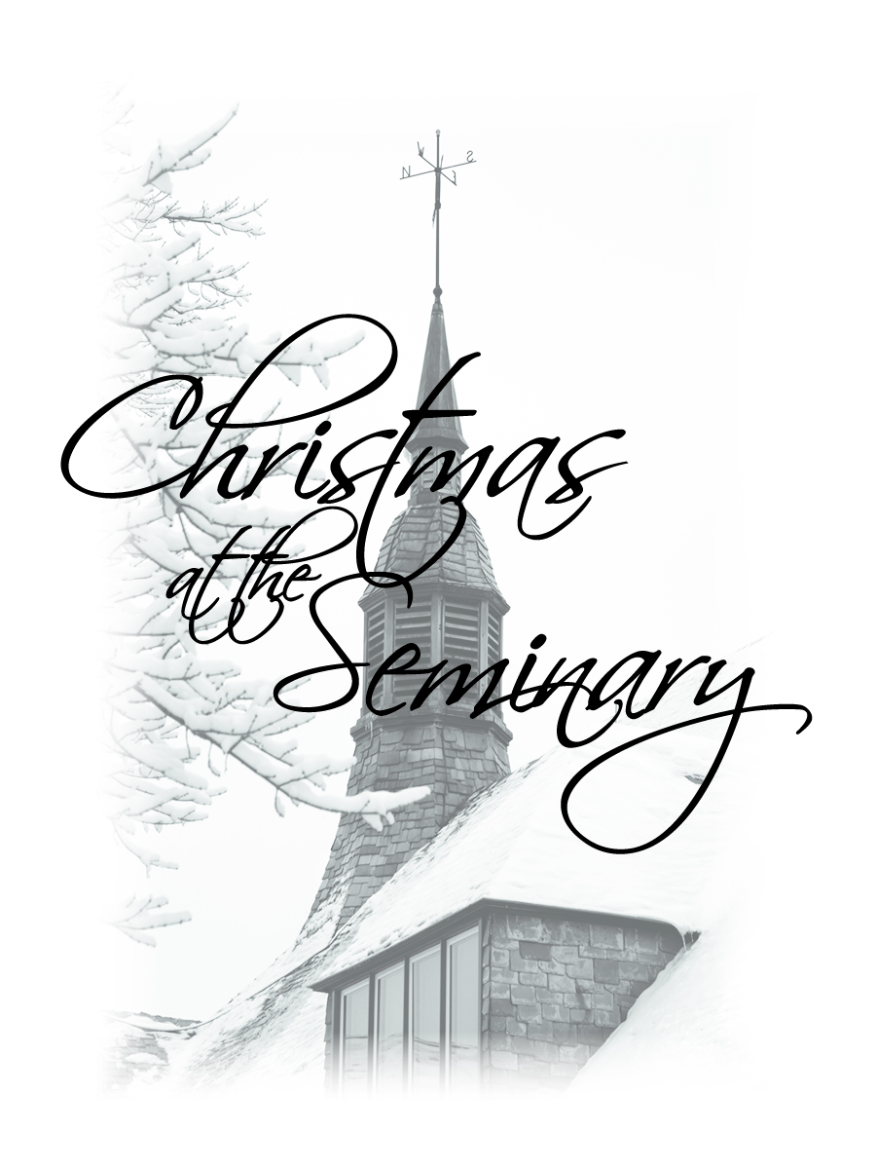

Wisconsin Lutheran Seminary Auditorium
___________________________

December 8, 2019

Welcome to Wisconsin Lutheran Seminary

The 61 men of the Seminary Chorus and their director are honored by your presence and pray the message proclaimed in this concert will strengthen your faith and touch your heart.

Over the span of its 88-year history, students who participated in the Seminary Chorus have sung a wide variety of “psalms, hymns, and songs of the Spirit” at their concerts. Obviously, settings of psalms and biblical canticles appear often on programs. Anthems composed by English and Russian composers dominate the traditional male chorus repertoire, and the chorus has performed many of them. American folk songs add interest for students and audiences, as does world music from places like Nigeria and Mexico. The good news about Jesus has a long history and a wide reach, and Christians across the centuries and the globe have created music for the choir to sing.
Invariably, however, the Seminary Chorus and its six directors returned to the hymn. St. Augustine called the hymn “Praise to God with music,” but we can be more focused than that. Specifically, the hymn is “the song of the congregation.” With its rhyming texts and metered tunes, hymns are songs that many worshipers can sing together. But the hymn is more than a group sing. Long ago Prof. Bruce Backer wrote: “Hymns are a response to God. We sing our hymns to God who has rescued us. As we praise and thank him, we repeat the great things he has done for us. Hymns enable the believer to exercise his ministry. In hymns the universal priesthood is in action. As the believer addresses God, he lays the Word of God close to the heart of his brothers and sisters by singing of the great things God has done” (Bruce Backer in Lutheran Worship). We think of hymns, therefore, as the congregation’s song of praise and proclamation.

The Oxford Dictionary of Music contends that Martin Luther is “literally the father of the congregational song.” Because of his training and in his own experience, Luther understood the power of the sung Word. He set his own hand to editing and writing hymns, both texts and tunes, and inspired others to do the same. Over the 250 years that followed Luther’s death, hundreds of poets and composers contributed to the Reformation legacy. Written by Lutherans and sung by Lutherans, this set of hymns has come to be known as the Lutheran chorale, the hymn of the Evangelical Lutheran Church. These hymns, as well as hymns that emulate them, form the core of Lutheran hymnals still today.

The order of service that Luther knew didn’t provide a place for the congregational hymn. As he revised the medieval mass, Luther replaced the historic graduals (psalms chanted between the Epistle and Gospel) with a hymn for the congregation. Eventually, other hymns were added to the service, but this hymn became the main hymn, the Hauptlied, or what we call the Hymn of the Day. As time passed, hymns were assigned to certain days to match the focus of the appointed Gospel. This sturdy Lutheran practice, lost for several centuries, has made a comeback in Lutheran orders of service and has become a regular part of our worship.

With only one exception, the music presented today comes from that corpus called the Lutheran chorale. These hymns take us back to our heritage, but they also demonstrate that these great hymns have never been used in only one form. The Lutheran chorale is at home in Bach’s Cantata 140, but it is also comfortable with Koiné.

Leaning on the experience of the past, the Church moves confidently into the future. This is the practical motto of the Seminary Chorus, not just at this concert but throughout its history. We treasure the great confessional hymns of the Lutheran Church and strive to present them to the best of our ability in new and vigorous ways. As we do, our musical efforts become paradigms for pastoral ministry.

May the Lord Jesus bless the Seminary Chorus.

James P. Tiefel

Prof. Tiefel has directed the chorus since 1985.

Lutheran Hymns of the Christmas Season

Crying children may be quieted in the auditorium lobby.
Please silence cell phones and electronic devices.
The 3:00 p.m. concert is being streamed live on the Internet.

The Season of Advent

O Lord, How Shall I Meet You Words by Paul Gerhardt (1607-1676)
Tune by Johann Crüger (1598-1662)
Setting Michael Costello, 2009

Stand for the final stanza
Be seated

Matthew 25:1-13

Wachet Auf, Ruft Uns die Stimme Words and tune by Philipp Nicolai (1556-1608)
Setting by Johann Sebastian Bach
Cantata 140 – BWV 140

1. Chorale  Wachet auf, ruft uns die Stimme,  der Wächter sehr hoch auf der Zinne,  wach auf, du Stadt Jerusalem.  Mitternacht heißt diese Stunde,  sie rufen uns mit hellem Munde,  wo seid ihr klugen Jungfrauen?  Wohlauf, der Bräut’gam kömmt,  steht auf, die Lampen nehmt, Alleluia!  Macht euch bereit zu der Hochzeit,  ihr müsset ihm entgegen gehn.  4. Chorale  Zion hört die Wächter singen,  das Herz tut ihr vor Freuden springen,  sie wachet und steht eilend auf.  Ihr Freund kommt von Himmel prächtig,  von Gnaden stark, von Wahrheit mächtig,  ihr Licht wird hell, ihr Stern geht auf.  Nun komm, du werte Kron’,  Herr Jesu, Gottes Sohn, Hosianna!  Wir folgen all zum Freudensaal  und halten mit das Abendmahl.  7. Chorale  Gloria sei dir gesungen,  mit Menschen- und englischen Zungen,  mit Harfen und mit Zimbeln schon.  Von zwölf Perlen sind die Pforten,  an deiner Stadt sind wir Konsorten  der Engel hoch um deine Thron.  Kein Aug’ hat je gespürt,  kein Ohr hat je gehört solche Freude,  des sind wir froh, io,io,  ewig in dulci jubilo. | Stanza 1  Wake, awake, for night is flying,  The watchmen on the heights are crying,  Awake, Jerusalem, arise!  Midnight hears the welcome voices  And at the thrilling cry rejoices:  Oh, where are all you virgins wise?  The Bridegroom comes—awake!  Your lamps with gladness take! Alleluia!  With bridal care yourselves prepare  To meet the Bridegroom who is near.  Stanza 2  Zion hears the watchmen singing,  And all her heart with joy is springing;  She wakes, she rises from her gloom,  For her Lord comes down all-glorious,  The strong in grace, in truth victorious;  Her Star is ris’n, her Light is come.  Now come, O Blessed One,  Christ Jesus, God’s own Son. Hail! Hosanna!  The joyful call we answer all  And follow to the wedding hall.  Stanza 3  Now let all the heav’ns adore you;  Let saints and angels sing before you  With harp and cymbal’s clearest tone.  Of one pearl each shining portal,  Where, dwelling with the choir immortal,  We gather round your radiant throne.  No vision ever brought,  No ear has ever caught such great glory;  Therefore will we in victory  Sing hymns of praise eternally.

O Holy Night Adolphe Adam (1803-1856)
Arranged by Jennifer Eklund, 2012

Ethan Schultz, pianist

The Season of Christmas
Luke 2:1-20

All Praise to Thee, Eternal Lord Words by Martin Luther (1483-1546)
Tune by Michael Praetorius (1571-1621)
Arranged by Robert Denham, 2007

All praise to thee, eternal Lord  Clothed in a garb of flesh and blood;  Choosing a manger for thy throne,  While worlds on worlds are thine alone.  Once did the skies before thee bow;  A virgin’s arms contain thee now,  While angels who in thee rejoice,  Now listen for thine infant voice.  A little child, thou art our guest,  That weary ones in thee may rest;  Forlorn and lowly is thy birth  That we may rise from heaven to earth. | Thou comest in the darksome night  To make us children of the light,  To make us in the realms divine,  Like thine own angels, round thee shine.  All this for us thy love hath done;  By this to thee our love is won!  For this we tune our cheerful lays  And sing our thanks in ceaseless praise.  All praise to thee, eternal Lord,  Clothed in a garb of flesh and blood;  Choosing a manger for thy throne,  While worlds on worlds are thine alone.

O Jesus Christ, Your Manger Is My Paradise Words by Paul Gerhardt (1607-1676)
Tune by Johann Crüger (1598-1662)
Arranged by Ruth Breiling, 2016

O Jesus Christ, your manger is
My paradise where my soul is reclining.
For there, O Lord, we find the Word
Made flesh for us—your grace is brightly shining.

He whom the sea and wind obey
Comes down to serve the sinner in great meekness.
Now God’s own Son with us is one
And joins us and our children in our weakness.

Dear Christian friend, on him depend;
Be of good cheer and let no sorrow move you.
For God’s own child in mercy mild
Joins you to him—how greatly God must love you!

The world may hold her wealth and gold;
But you, my heart, keep Christ as your true treasure.
To him hold fast until at last
A crown is yours and honor in full measure.

Freuet Euch, Ihr Christen Alle Christian Keimann (1607-1662)
Setting by Andreas Hammerschmidt (1611-1675)
Arranged by Martin Albrecht (1908-1993)
Setting by Ian Welch and Mark Tiefel, 2009

Freuet euch, ihr Christen alle!  Freue sich, wer immer kann,  Gott hat viel an uns getan.  Freuet euch mit großem Schalle,  Daß er uns so hoch geacht't,  Sich mit uns befreund't gemacht.  Freude, Freude ueber Freude!  Christus wehret allem Leide.  Wonne, Wonne über Wonne!  Er ist die Gnadensonne. | Oh, rejoice, all Christians, loudly,  For our joys have now begun;  Wondrous things our God has done.  Tell abroad his goodness proudly,  Who our race has honored so,  That he lives with us below.  Joy, oh, joy beyond all gladness,  Christ has done away with sadness!  Hence all sorrow and repining,  For the Sun of grace is shining!
Siehe, siehe, meine Seele,  Wie dein Heiland kommt zu dir,  Brennt in Liebe für und für,  Daß er in der Krippe Höhle  Harte lieget dir zugut,  Dich zu lösen durch sein Blut.  Freude, Freude ueber Freude!  Christus wehret allem Leide.  Wonne, Wonne über Wonne!  Er ist die Gnadensonne. | See, my soul, your Savior chooses  Poverty and weakness, too;  In such love he comes to you.  Neither crib nor cross refuses,  All he suffers for your good  To redeem you by his blood.  Joy, oh, joy beyond all gladness,  Christ has done away with sadness!  Hence all sorrow and repining,  For the Sun of grace is shining!
Jesu, wie soll ich dir danken?  Ich bekenne, daß von dir  Meine Seligkeit herrühr'.  O laß mich von dir nicht wanken,  Nimm mich dir zu eigen hin,  So empfindet Herz und Sinn  Freude, Freude ueber Freude!  Christus wehret allem Leide.  Wonne, Wonne über Wonne!  Er ist die Gnadensonne. | Lord, how shall I thank you rightly?  I am saved eternally  By your life and death for me.  Let me not regard you lightly  But on you in faith depend,  Praising you, my heav’nly friend.  Joy, oh, joy beyond all gladness,  Christ has done away with sadness!  Hence all sorrow and repining,  For the Sun of grace is shining!
Jesu, nimm dich deiner Glieder  Ferner in G’naden an!  Schenke, was man bitten kann,  Zu erquicken deine Brüder;  Gib der ganzen Christenschar  Frieden und ein sel'ges Jahr.  Freude, Freude ueber Freude!  Christus wehret allem Leide.  Wonne, Wonne über Wonne!  Er ist die Gnadensonne. | Jesus, guard and guide your members;  Make us children of your grace;  Hear our prayers in ev’ry place.  Fan to life faith’s glowing embers;  Give all Christians far and near  Holy peace, a glad new year.  Joy, oh, joy beyond all gladness,  Christ has done away with sadness!  Hence all sorrow and repining,  For the Sun of grace is shining!

Rejoice, Rejoice, Ye Christians German author unknown
Tune by Leonhart Schröter (1532-1601)
Arranged by Don Malin, 1959

Rejoice, rejoice, ye Christians with all your hearts this morn!
Oh, hear the blessed tidings: The Lord, the Christ, is born.
Now brought us by the angels that stand about God’s throne;
Oh, lovely are the voices that make such tidings known.

Oh, harken to their singing: This Child shall be your friend.
The Father so hath willed it. That thus your woes should end;
The Son is freely given that in him ye may have
The Father’s grace and blessing and know he loves to save.

Nor deem the form too lowly that clothes him at this hour;
For know ye what it hideth? ‘Tis God’s almighty power.
Though now within the manger so poor and weak he lies,
He is the Lord of all things; he reigns above the skies.

Come, Your Hearts and Voices Raising Words by Paul Gerhardt (1607-1676)
German tune from Breslau, 1555
Arranged by Koiné, 2019

Come, your hearts and voices raising,
Christ the Lord with gladness praising;
Loudly sing his love amazing,
Worthy folk of Christendom.

See how God, for us providing,
Gave his Son and life abiding;
He our weary steps is guiding
From earth’s woe to heav’nly joy.

Christ, from heav’n to us descending
And in love our race befriending,
In our need his help extending,
Saved us from the wily foe.

Jacob’s Star in all its splendor
Beams with comfort sweet and tender,
Forcing Satan to surrender,
Breaking all the pow’rs of hell.

Gracious Child, we pray you, hear us;
From your lowly manger cheer us.
Gently lead us and be near us
Till we join th’ angelic choir.

Let All Together Praise Our God Words and tune by Nikolaus Herman (1480-1561)
Arranged by Richard Gieseke, 1984

Stand and sing
Be seated

Offering An ambitious Easter tour takes the chorus to congregations in
Idaho, Washington, Oregon, California, and Minnesota. Since the choir receives income
only from offerings and CD sales, your generous gift is appreciated.

Chorales for Trombone Choir Edited by Robert King, 1958

Savior of the Nations, Come  Behold, a Branch Is Growing  Comfort, Comfort, All My People | From Heaven above to Earth I Come  This Day to Us a Child is Born  Once Again My Heart Rejoices

Christian Willick, horn; Andrew Krueger, horn; Daniel Wessel, trombone; Justin Steinke, trombone.

The Season of Epiphany
Matthew 2:1-12

The Only Son from Heaven Elizabeth Cruciger (1500-1535)
Setting by John Behnke, 2005

The only Son from heaven, foretold by ancient seers,
By God the Father given, in human form appears.
No sphere his light confining, no star so brightly shining
As he, our Morning Star.

Oh, time of God appointed, O bright and holy morn!
He comes, the King anointed, the Christ, the virgin-born,
Grim death to conquer for us, to open heav’n before us
And bring us life again.

Awaken, Lord, our spirit to know and love you more,
In faith to stand unshaken, in spirit to adore,
That we, through this world moving, each glimpse of heaven proving,
May reap its fullness there.

O Father, here before you with God the Holy Ghost
And Jesus, we adore you, O Pride of angel host.
Before you mortals lowly cry “Holy, holy, holy,”
O blessed Trinity!

I Want to Walk as a Child of the Light Words and melody by Kathleen Thomerson
Arranged by Tom Trenney

I want to walk as a child of the light; I want to follow Jesus.
God set the stars to give light to the world; the star of my life is Jesus.
In him there is no darkness at all; the night and the day are both alike.
The Lamb is the light of the city of God. Shine in my heart, Lord Jesus.

I want to see the brightness of God; I want to look at Jesus.
Clear Sun of Righteousness, shine on my path and show me the way to the Father.
In him there is no darkness at all; the night and the day are both alike.
The Lamb is the light of the city of God. Shine in my heart, Lord Jesus.

Prayer and Blessing

Almighty God, you made Christmas shine with the brightness of the true Light. Grant that we who have known on earth the wonder of that Light may also behold him in all his glory in the life to come; through Jesus Christ our Lord.
Amen.

May he who by his incarnation gathered into one things earthly and heavenly, fill us with such joy that comes with the knowledge of the forgiveness of sins and the hope of eternal life. And the blessing of God Almighty, the Father, the Son, and the Holy Spirit, be upon you and remain with you always.
Amen.
How Lovely Shines the Morning Star Words and tune by Philipp Nicolai (1556-1608)
Setting by Charles Ore, 1996

In memory of David Tiefel
Lord, When Your Glory I Shall See Words by Paul Gerhardt (1607-1676)
Tune by Kurt J. Eggert (1923-1993)
Arranged by Carl F. Schalk, 1992

Commissioned in 1992 to honor the ministry of Pastor Kurt Eggert, this anthem has become the signature anthem of the Chorus and concludes every concert and appearance.

Lord, when your glory I shall see and taste your kingdom's pleasure,
Your blood my royal robe shall be, my joy beyond all measure!
When I appear before your throne, your righteousness shall be my crown;
With these I need not hide me. And there, in garments richly wrought,
As your own bride I shall be brought to stand in joy beside you.

After the 3:00 p.m. concert guests who desire to visit the seminary’s chapel, library, classrooms, and recently renovated circle are invited to exit the auditorium via the east entrance, walk under the tower, and turn right toward the library entrance: Thy Word is Truth. Student guides will welcome you.

Compact discs of recent recordings produced by the Seminary Chorus, including the 2010 recording, Christmas at the Seminary, are available for sale following the concert for $12.00. Also for sale is a compendium of recordings from 1995 to 2016 entitled The Seminary Chorus: Across the Years, Across the Miles. Anthems by the Seminary Chorus are available on Spotify, iTunes, and Apple Music.

The Chorus thanks members of the seminary staff for all they do to make the annual Christmas concert an enjoyable and faith-building experience.

The Schimmel Piano

The seminary is pleased to introduce the Schimmel Konzert K230 Tradition grand piano. The 7’ 6” concert instrument, manufactured this past fall by Schimmel Pianos of Brunswick, Germany, replaces a smaller piano purchased by the seminary in 1960. Funding for the piano was provided by an anonymous donor in thanksgiving for the seminary, the Seminary Chorus, and the 35-year ministry of Prof. James Tiefel.

The seminary thanks not only the donor but also Pastor Aaron Christie who guided the selection and purchase of the piano and Jim Laabs of the Jim Laabs Music Store, Stevens Point, WI, for his gracious support of this project.

Acknowledgments

I Want to Walk as a Child of the Light – Text © 1970, 1975 Celebration. All rights reserved.

Concert Participants

Reader Prof. Earle D. Treptow
President of the Seminary

Guest Accompanist Kevin Becker
Grace, Milwaukee, WI

Chorus Accompanists Christian Willick, Erik Lund, Collin Wenzel,
Evan Arrowsmith, and Matthew Zeng

Guest Instrumentalists Jack Boatman, violin
Grace, Milwaukee, WI
Pastor Greg Sitzman, violin
Emanuel Redeemer, Yale, MI
Lori Guse, viola
Morning Star, Jackson, WI
Aaron Zauner, cello
St. Marcus, Milwaukee, WI
Katherine Dogs, oboe
Christ the Lord, Brookfield, WI
Alana Laufman, oboe
Redeemer, Rice Lake, WI
Tom Schlueter, trumpet
Christ the Lord, Brookfield, WI

Chorus Instrumentalists Matthew Hatzung, trumpet
Joshua Koelpin, trumpet
Christian Willick, horn
Andrew Krueger, horn
Justin Steinke, trombone
Daniel Wessel, trombone
Jeremiah Wallander, timpani
Jacob Schlomer, acoustic guitar
Zachary Satorius, electric guitar
Daniel Wessel, bass guitar
Thomas Rockhoff, drums
Jeremiah Wallander, sleigh bells

Chorus Officers Caleb Klatt, president
Paul Bourman, vice president

The Seminary Chorus

Tenor I |  | Tenor II
Conifer Berg | Milwaukee, WI | Evan Arrowsmith | Bay City, MI
Ethan Boese | Waukesha, WI | Paul Bourman | Flushing, NY
Joshua Frailing | Appleton, WI | Aaron Bush | New Berlin, WI
Nathan Jenswold | DeForest, WI | Barton Cox | Oconomowoc, WI
Andrew Krueger | Findlay, OH | Nicolas Gartner | Maple Grove, MN
Alex Lindemann | Lewiston, MN | Nathanael Goelzer | Deltona, FL
Erik Lund | Doral, FL | Matthew Hatzung | Maplewood, MN
Thomas Rockhoff | Wichita, KS | James Hemmelman | Winona, MN
Jeremiah Wallander | Menasha, WI | Joseph Kasper | Thomasville, GA
Zachary VonDeylen | Friendswood, TX | Joshua Koelpin | New Ulm, MN
Christian Willick | Elm Grove, WI | Micah Koelpin | Dallas, TX
 |  | Stephen Oelhafen | Waukesha, WI
 |  | Christopher Royce | Green Bay, WI
 |  | Zachary Satorius | Annandale, VA
 |  | Nathaniel Savage | Phoenix, AZ
 |  | Nathan Schleef | Jackson, WI
 |  | Samuel Schulz | DeForest, WI
 |  | Daniel Wessel | New Ulm, MN
Bass I |  | Bass II
Christian Arnold | Oconto Falls, WI | Robert Beaver | Oconomowoc, WI
Simeon Crass | Ortonville, MI | Jacob Brohn | Hudson, WI
Charles Crass | Ortonville, MI | Karl Christie | Waukesha, WI
Grant Freese | Plymouth, NE | Justin Digman | Fond du Lac, WI
Grant Hagen | Appleton, WI | Jonathan Fleischmann | Kaukauna, WI
Jacob Heyn | Phoenix, AZ | Nicolas Jenswold | DeForest, WI
Caleb King | Lomira, WI | Alexander Kirchenwitz | Weston, WI
Jared Lindemann | Egg Harbor, WI | Caleb Klatt | New Hope, MN
Samuel Lor | Kansas City, KS | Joel Prange | Burlington, WI
Jonathan Neumann | Ellensburg, WA | Jacob Roecker | Campbellsport, WI
Jacob Schlomer | Helenville, WI | Collin Wenzel | Appleton, WI
Daniel Schmidt | Bittern Lake, AB | Nathan Wong | New Ulm, MN
Ethan Schultz | Waukesha, WI | Eric Zabell | Green Bay, WI
Daniel Spaude | Antigo, WI
Justin Steinke | San Antonio, TX
Hugo Ugalde-Bemer | Cedar Rapids, IA
Jordan Uhlhorn | Scottsdale, AZ
Philip Waldschmidt | Greenfield, WI
Matthew Zeng | Roseville, MN

Program Notes

O Lord, How Shall I Meet You Christian Worship 18

Paul Gerhardt, the author of this hymn, is thought by many to be the greatest of Lutheran hymn writers. He worked together at St. Nicholas Church in Berlin with a faithful and talented musician, Johann Crüger, who composed many of the tunes that accompany Pastor Gerhardt’s texts. It has been chosen as the Hymn of Day for The Third Sunday in Advent in our new hymnal. The arranger, Pastor Michael Costello, is cantor at Grace Lutheran Church, River Forest, IL.

Wake, Awake, for Night Is Flying Christian Worship 206
Wachet auf, ruft uns die Stimme

This powerful and familiar hymn, often referred to as the “King of Chorales,” was written by Philipp Nicolai, a German Lutheran pastor who also wrote the hymn’s tune. The hymn is based on Jesus’ parable of the wise and foolish virgins who await the master’s return. The hymn is invariably selected as the Hymn of the Day when that Gospel account is read, traditionally on the last Sunday of the church year. Because of its preparation theme, the hymn is often sung in Advent. As kantor in Leipzig, Johann Sebastian Bach was responsible for preparing the Cantata, the primary service music in Lutheran churches at this time. Bach’s church cantatas included both the stanzas of the hymn and poetic interpretations of the Gospel text sung by solo voice. The Chorus presents the stylized settings of the three original stanzas of Nicolai’s hymn.

All Praise to Thee Eternal Lord Christian Worship 33

The first stanza of this hymn comes from the 13th century and was sung by worshipers on Christmas Day. Martin Luther added six additional stanzas in 1523. This hymn with its original tune was selected at the Hymn of the Day for Christmas Day in CW. The setting sung by the Chorus matches Luther’s text to another Reformation tune, PUER NOBIS NASCITUR, arranged by Lutheran church musician Michael Praetorius. Arranger Robert Denham is a noted American composer and teacher.

O Jesus Christ, Your Manger Is My Paradise Christian Worship 40

Perhaps more than any of his hymns, this text reflects Paul Gerhardt’s sturdy faith as a “theologian strained in Satan’s sieve,” who endured heartbreak and tragedy throughout his ministry. The tune was composed especially for this text by Gerhardt’s colleague, Johann Crüger. The arrangement is by WELS member Ruth Breiling from Prescott Valley, AZ, who offered the use of her setting to the Seminary Chorus this past summer. We thank her.

Oh, Rejoice, Ye Christians Loudly Christian Worship 45
Freuet Euch, Ihr Christen Alle

This stirring and popular Christmas hymn is by Pastor Christian Keimann and was written for his academy students in 1645. Keimann, like Paul Gerhardt, was blessed to serve with a talented musician, Andreas Hammerschmidt, who composed many of the tunes for Keimann’s hymns. The original setting was for a favoriti choir of men and mixed choir and was prepared for the Chorus in 1962 by long-time director, Prof. Martin Albrecht. The hymn is newly chosen as the alternate Hymn of the Day for Christmas Day.

Rejoice, Rejoice, Ye Christians

While the author of this hymn text is unknown, the composer of the tune is not. Leonhart Schröter lived in Torgau, Germany, and studied music under Johann Walter, Luther’s protégé and first Lutheran cantor. The arrangement is by Father Don Malin who served as a music minister in Roman Catholic churches for many years.

Come, Your Hearts and Voices Raising Christian Worship 42

This is another of Paul Gerhardt’s Christmas hymns. It was included in a collection of Gerhardt hymns edited by Johann Crüger’s successor at St. Nicholas, Johann Ebeling (1637-1676) who also composed several tunes for Gerhardt’s texts. The arrangement is by Koiné, the Milwaukee-based worship ensemble which has helped us to see that the great hymns of the Evangelical Lutheran Church can contribute to our worship life in many forms and styles.

Let All Together Praise Our God Christian Worship 41

Both the text of this hymn and its tune were created by Nikolaus Herman, church musician at Joachimstahl in Bohemia. He was supported by his pastor, Johann Matthesius, renowned as the first compiler of Luther’s Table Talk. Among Herman’s hundreds was a set of hymns for every Sunday of the church year. Herman’s legacy is said to have preserved the congregation in Joachimstahl even after Catholic forces conquered the city. The laity had memorized his hymns! Richard Gieseke served congregations in the Lutheran Church-Missouri Synod for many years. The hymn is designated as the Hymn of the Day for the Sunday after Christmas.

The Only Son from Heaven Christian Worship 86

Elizabeth Cruciger, a close friend of Luther’s wife Katherine, is described as a woman of rare musical gifts and a model wife and mother. She lived in Wittenberg with her husband Casper, one of Luther’s most devoted and talented students. She seems to have written the hymn to match the tune of a German folk song, and it is this tune which usually accompanies her text. John Behnke, long-time professor at Concordia University-Wisconsin and cantor at Trinity Lutheran Church, Milwaukee, created the new tune and setting for his church choir at Trinity. The hymn will be the Hymn of the Day for the Second Sunday after Christmas as it has been for the Second Sunday after the Epiphany.

I Want to Walk as a Child of the Light

Kathleen Thomerson’s well-loved hymn found a place on the Chorus’ fall program and will remain in its repertoire for the Easter tour. It was chosen for this concert because of its obvious Epiphany connections. Tom Trenney is a church musician in Lincoln, NE.

How Lovely Shines the Morning Star Christian Worship 79

Philipp Nicolai wrote both the text and tune of this hymn, often called the “Queen of Chorales,” with the same grandeur as “Wake, Awake, for Night Is Flying.” The hymn is the Hymn of the Day for the Epiphany of Our Lord in virtually every Lutheran hymnal. The arranger of the setting, with its magnificent solo trumpet part, is Charles Ore, long-time professor of music at Concordia University-Seward, NE. The choral stanza of this year follows the translation supplied by Ore’s setting.

Lord, When Your Glory I Shall See Christian Worship 219

This text is the final stanza of Paul Gerhardt’s Lenten hymn, “A Lamb Goes Uncomplaining Forth.” When the committee which created Christian Worship: A Lutheran Hymnal decided to shorten the hymn by dropping several stanzas, including this stanza, many felt the stanza needed to be preserved. Kurt Eggert was among them and soon created the tune WEDDING GLORY. The setting by Dr. Carl Schalk was commissioned by the Seminary Chorus in 1992 to honor Pastor Eggert’s service to the synod and remains the choir’s signature anthem.

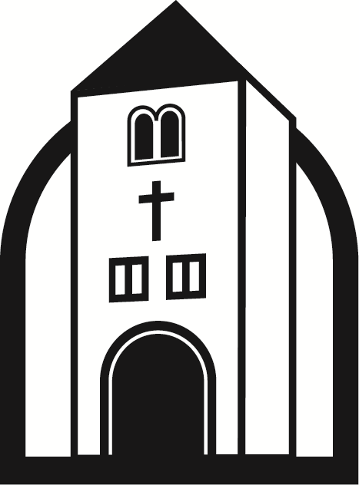

______________________

Wisconsin Lutheran Seminary
11831 North Seminary Drive Mequon, Wisconsin 53092 www.wls.wels.net

